

**Deploying a Transit Gateway within a Transit VPC on AWS**

[http://www.paloaltonetworks.com](http://www.paloaltonetworks.com/)

© 2019 Palo Alto Networks. Proprietary and Confidential

Table of Contents

Version History 3

1. About 4

2. Topology 4

3. Support Policy 6

4. Prerequisites 6

5. Create S3 Buckets for Security VPC 6

6. Deploy the Transit Gateway Stack 9

9. When everything works 13

10. Accessing the Firewall 15

11. Cleanup 15

# Version History

|  |  |
| --- | --- |
| **Version number** | **Comments** |
| **1.0** | Initial GitHub check-in |

# About

This document will explain how to deploy an AWS Transit Gateway as part of a Transit VPC with the VM-Series on AWS. A Transit VPC uses a hub and spoke architecture that allows security teams to centralize secure connectivity for VPC-to-VPC, VPC to corporate and VPC to the internet communications.

AWS Transit Gateway is a service that enables customers to connect their Amazon Virtual Private Clouds (VPCs) and their on-premises networks to a single gateway. As you grow the number of workloads running on AWS, you need to be able to scale your networks across multiple accounts and Amazon VPCs to keep up with the growth. Today, you can connect pairs of Amazon VPCs using peering. However, managing point-to-point connectivity across many Amazon VPCs, without the ability to centrally manage the connectivity policies, can be operationally costly and cumbersome. For on-premises connectivity, you need to attach your AWS VPN to each individual Amazon VPC. This solution can be time consuming to build and hard to manage when the number of VPCs grows into the hundreds.

With an AWS Transit Gateway, you only have to create and manage a single connection from the central gateway in to each VPC, on-premises data center, or remote office across your network. Transit Gateway acts as a hub that controls how traffic is routed among all the connected networks which act like spokes. This hub and spoke model simplifies management and reduces operational costs because each network only connects to the Transit Gateway and not to every other network. Any new VPC is simply connected to the Transit Gateway and is then automatically available to every other network that is connected to the Transit Gateway. This ease of connectivity makes it easy to scale your network as you grow.

More information on the AWS Transit Gateway can be found here: <https://aws.amazon.com/transit-gateway/>

# Topology

The topology below displays the VPCs and subnets that will be deployed. The Security or Firewall hub will provide security inspection and connectivity while the Transit Gateway will facilitate communications for the application VPCs. This topology is deployed in a single account:

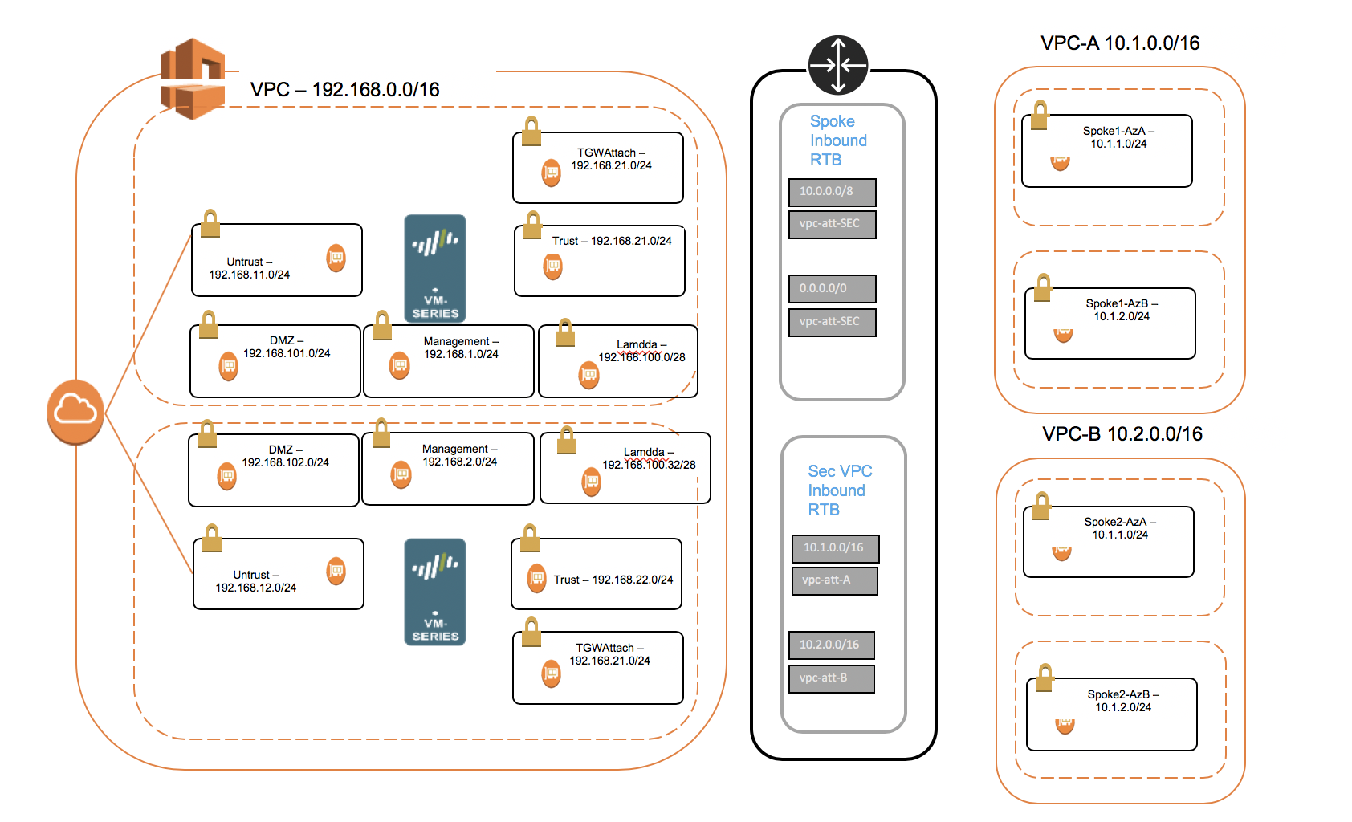



# Support Policy

This solution is released under an as-is, best effort, support policy. These scripts should be seen as community supported and Palo Alto Networks will contribute our expertise as and when possible. We do not provide technical support or help in using or troubleshooting the components of the project through our normal support options such as Palo Alto Networks support teams, or ASC (Authorized Support Centers) partners and backline support options. The underlying product used (the VM-Series firewall) by the scripts or templates are still supported, but the support is only for the product functionality and not for help in deploying or using the template or script itself.

# Prerequisites

Here are the prerequisites required to successfully launch this template:

* 1. AWS account
  2. Clone or download the files from the following GitHub repository on to your local machine: https://github.com/wwce/transitgateway

# Create S3 Buckets for Security VPC

In the AWS S3 console, create an S3 bucket with config, content, license and software folders.

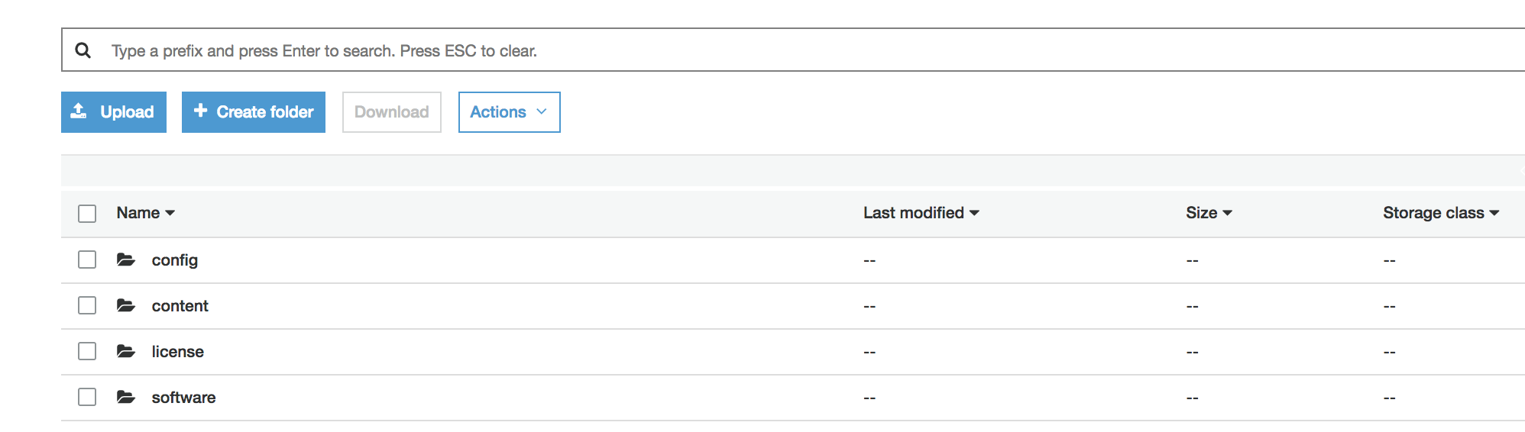

In the config folder add the VM-Series bootstrap.xml and init-cfg.txt files from the cloned repositories /bootstrap folder

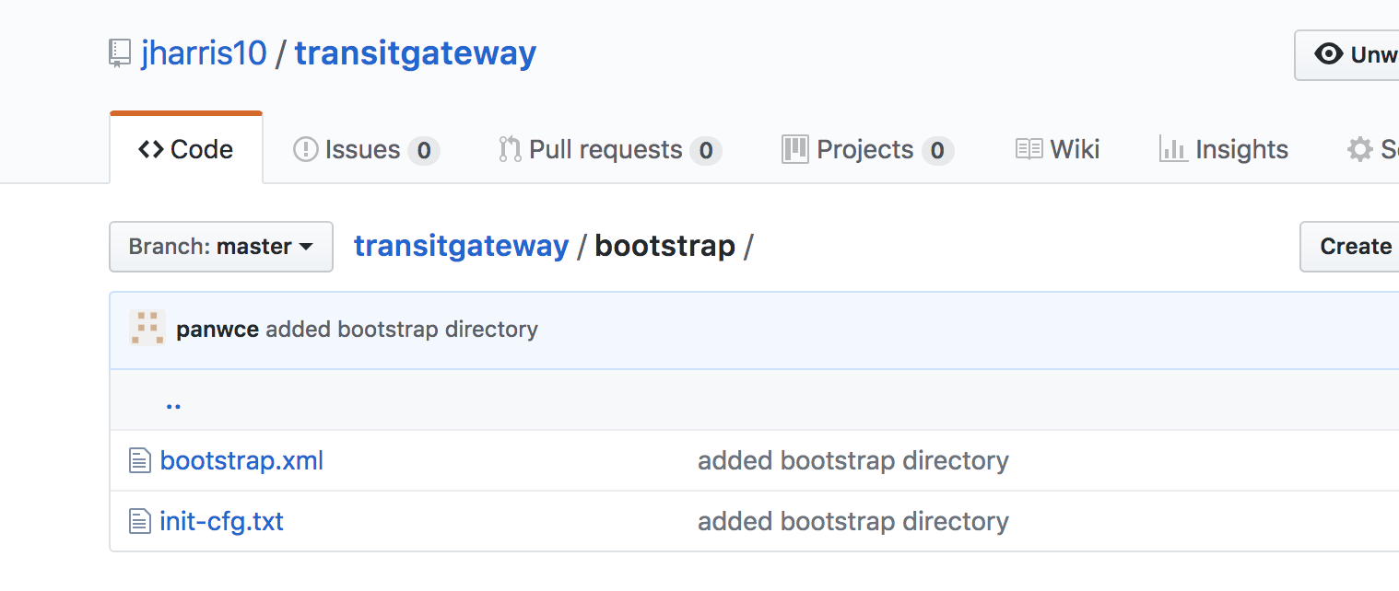

Either create another S3 bucket or use the existing bucket and add the Lambda.zip, TransitGatewayRouteMonitorLambda.zip and the InitialiseFwLambda.zip files from the Lambda directory in the cloned repository into this bucket.

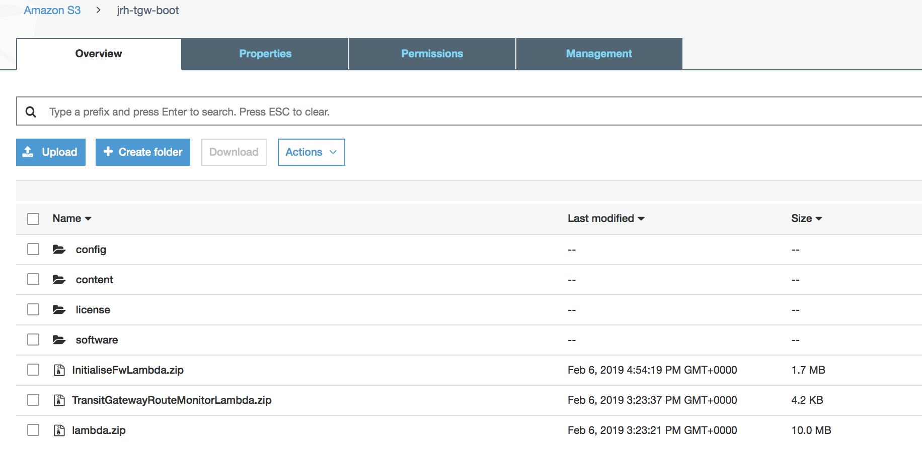

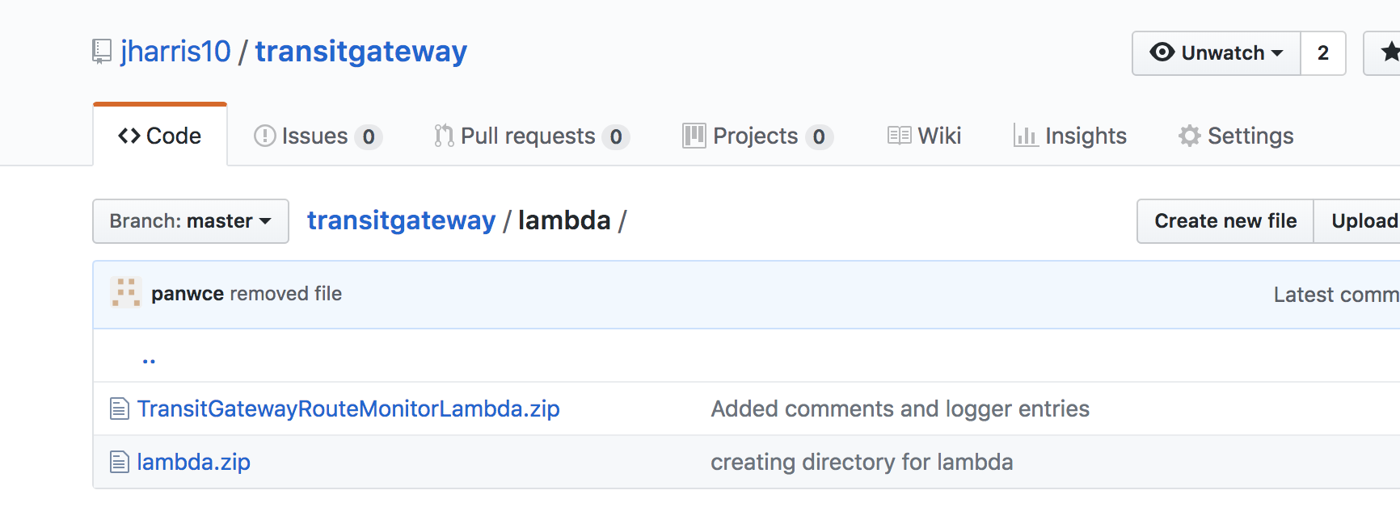

### Note: The buckets need to be in the same region in which you will deploy the Transit Gateway template.

# Deploy the Transit Gateway Stack

In the AWS CloudFormation console create a new stack and select the Transit-Gateway-Demo-v0.5.yaml template and fill in the parameters

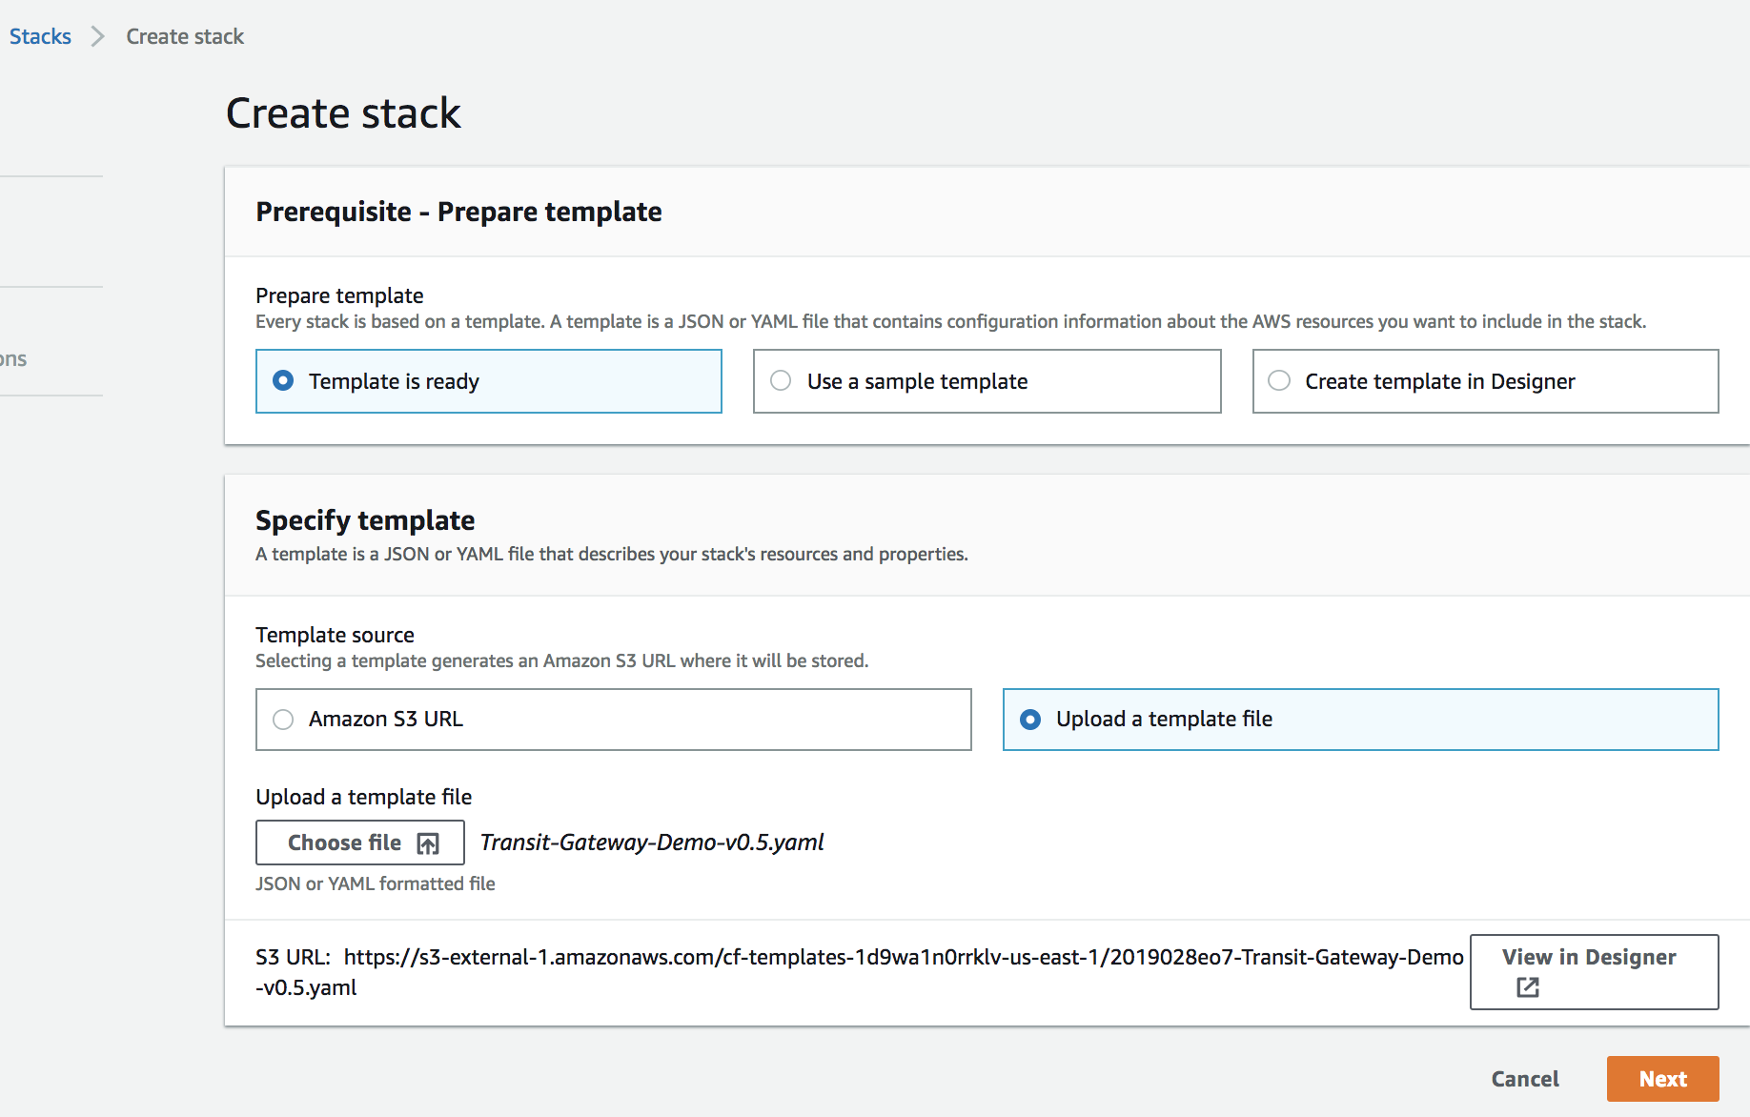

1. Route Monitor Configuration
   1. The first section configures the behaviour of the route failover Lambda function.
   2. RouteFailover – Setting this to true will return the route table to the original configuration where firewall 1 is used for internet connections and firewall 2 is used for east/west connections.
   3. SplitRoutes – Setting this value to false will result in a single firewall handling both internet connections and east/west connections

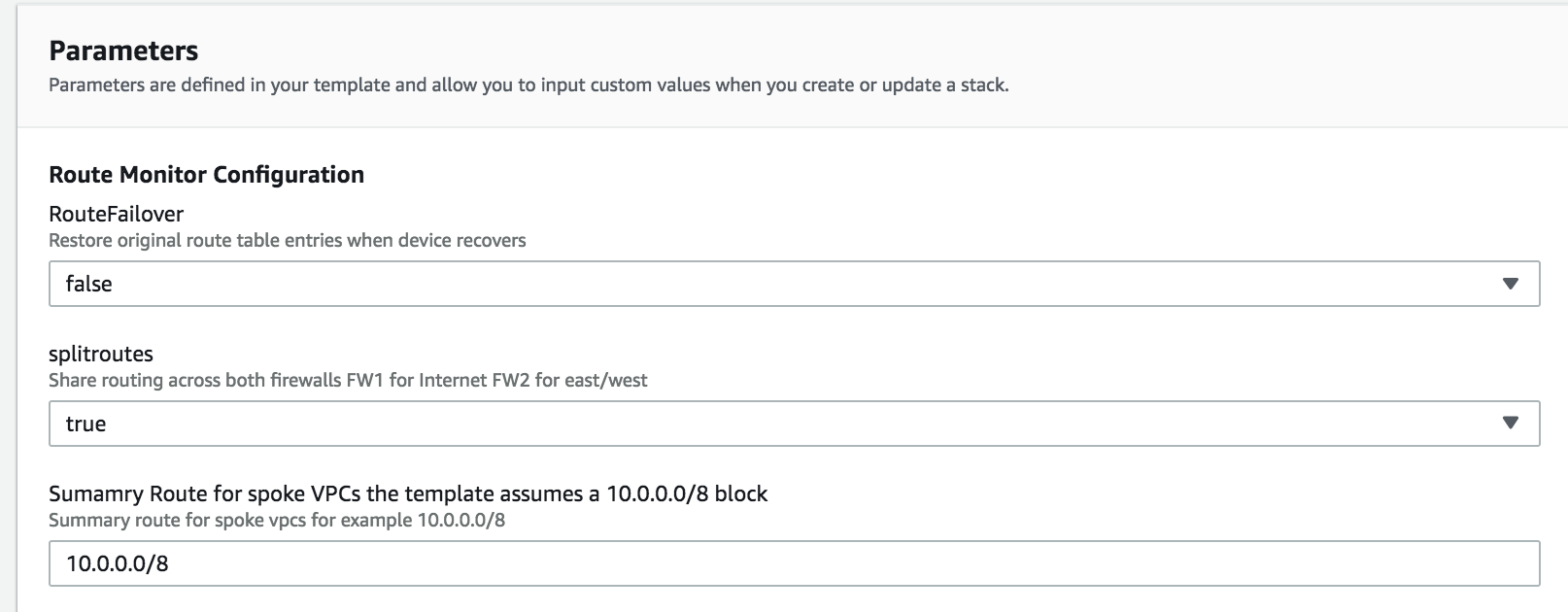

1. Security VPC Subnet Configuration

The template assumes that the default subnet values are used. It may be necessary to modify the existing bootstrap.xml file in the bootstrap folder if the network configuration changes.

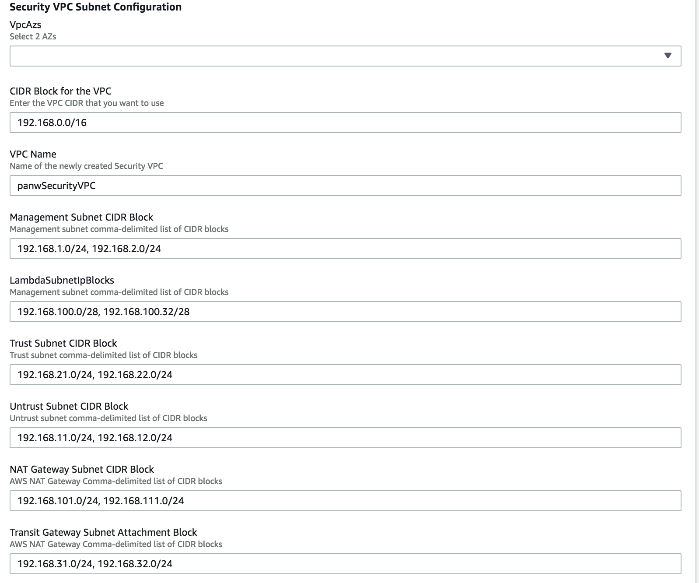

1. Lambda Configuration  
   Enter the name of the Lambda zip files you uploaded previously and the name of the S3 bucket they are stored in. Note: The S3 bucket must be in the same region as the stack deployment.

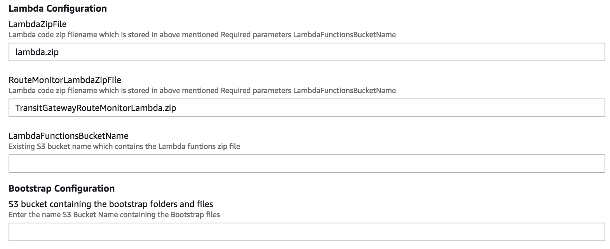

1. Other Parameters

Complete the remaining fields and Click through to kick of stack creation

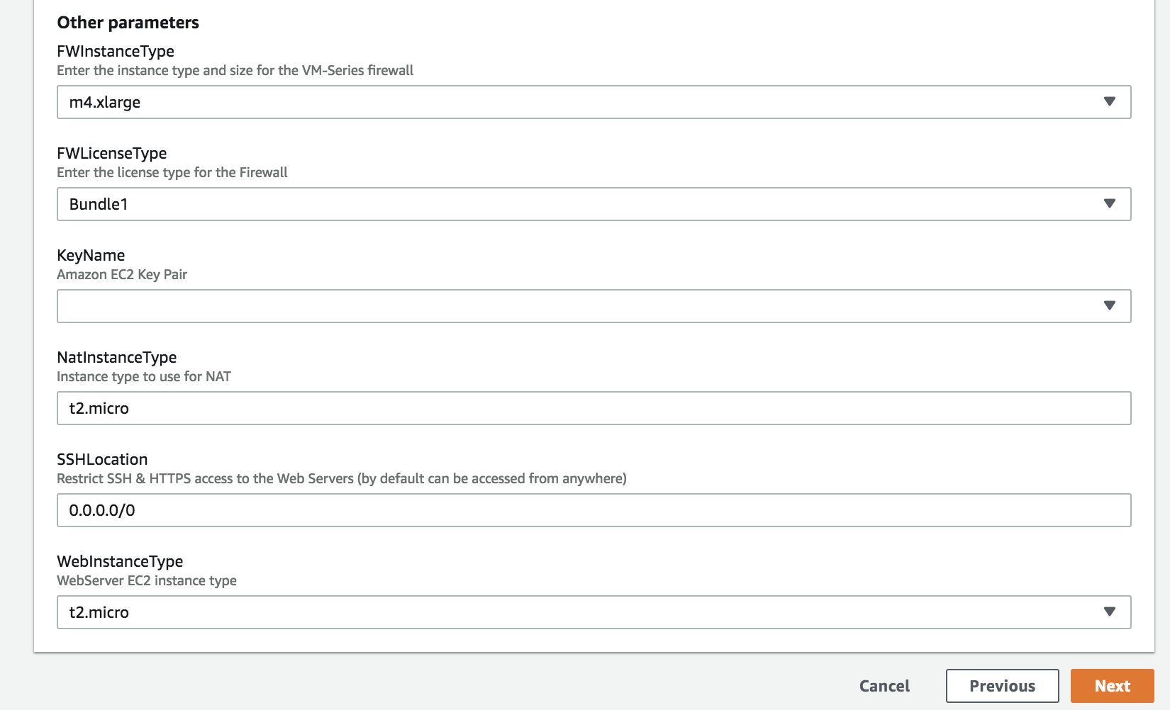

Click through to kick of stack creation.

You should see a stack create complete when the transit VPC account has been successfully initialized.

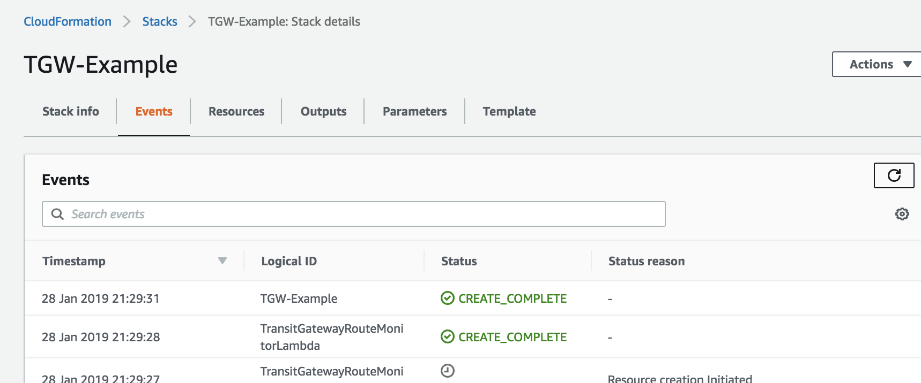

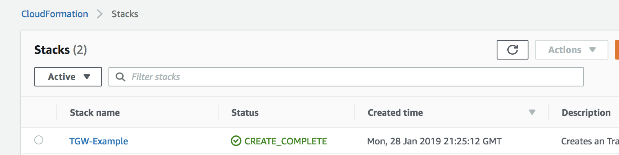

# When everything works

.You should see a “create_complete” status if the template had deployed correctly



In the screenshot below, you can see a pair of VM-Series firewalls, depicted as TGW-Example FW1 and FW2:

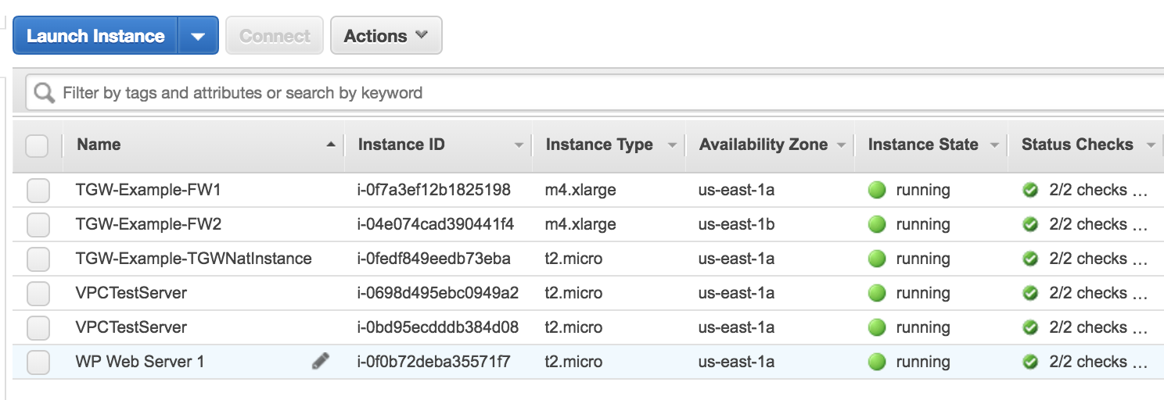

## Verify the Setup

### Lambda Functions

The TransitGatewayInitialiseLambda function updates the VPC subnet route tables with the next hop of the transit gateway. We use Lambda to create these routes as at this time we cannot accomplish this with the CloudFormation Template. The function also starts a lambda step function that runs some post deployment configuration tasks on the firewalls. In this case its sets a static route for the spoke VPCs and updates and address object with the firewalls untrust IP assigned by AWS.



Figure 1 Routes Added to VPC Route Tables

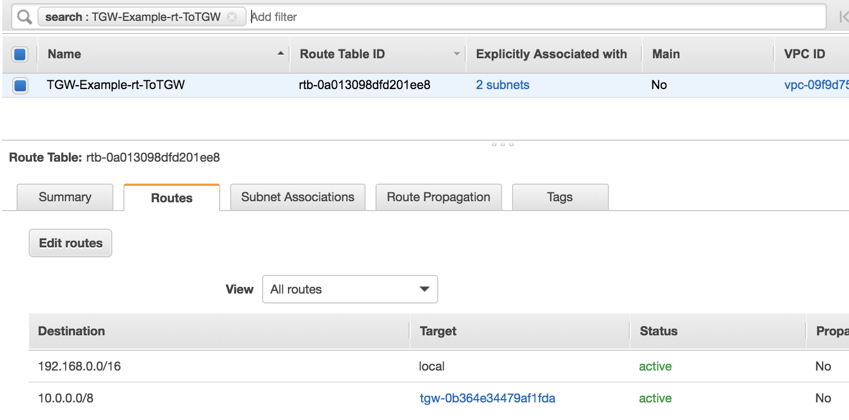

Figure 2 Routes added to the VPC route table

You can view this step function event in the CloudWatch logs associated with the lambda script



Figure 3 TGWInitialiseLambda Starting Step Function

The step function runs the InitialiseFWLambda function

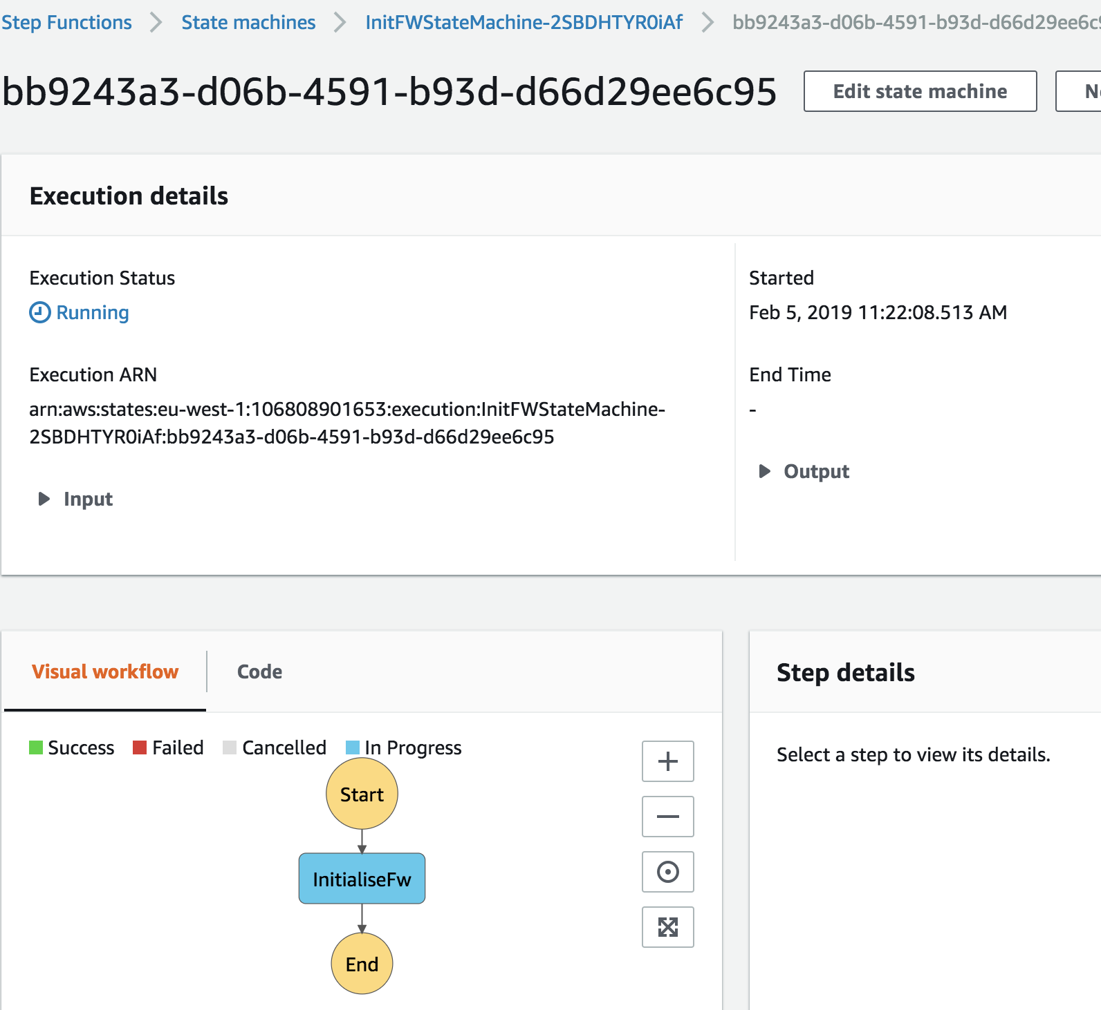

Figure 4 Step Function Status

When the step function completes you will see the status update

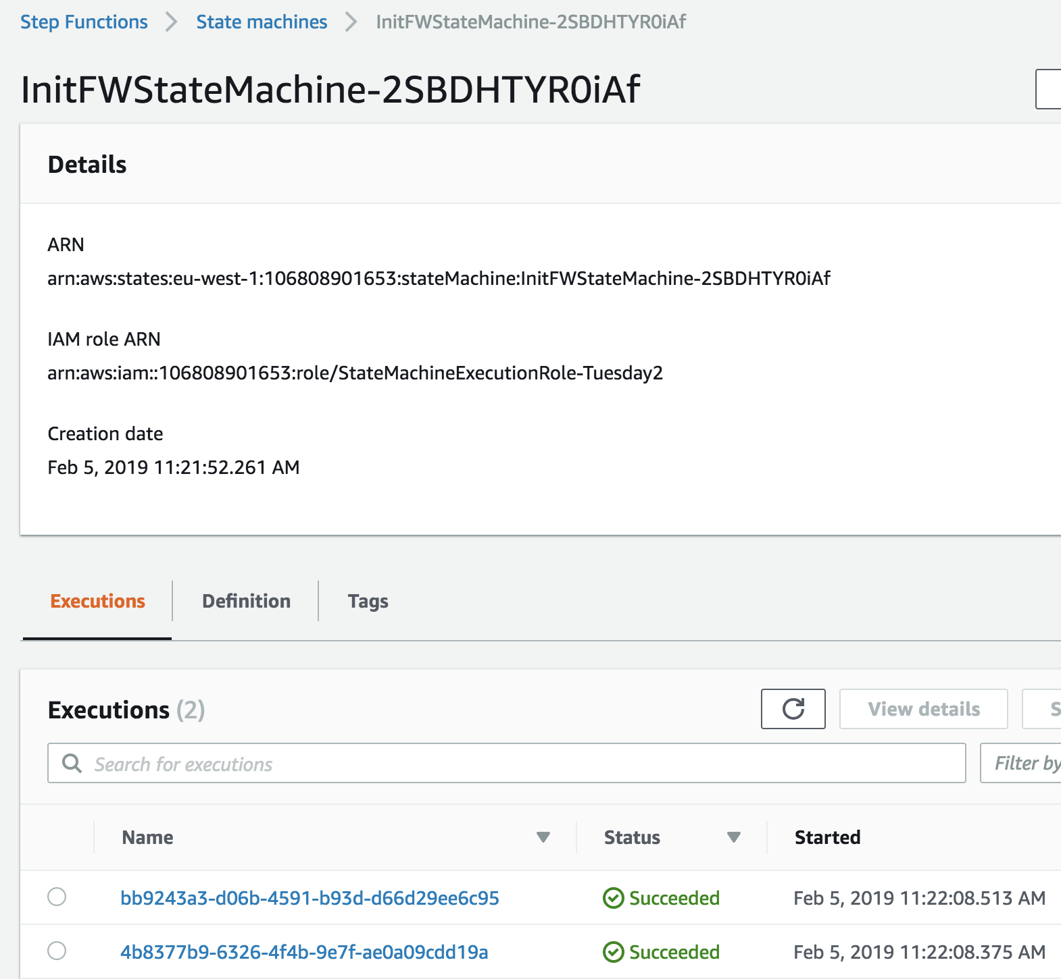

Figure 5 Successful Step Function



Figure 6 Output from InitialiseFwLambda function

Once the stack build has completed go to the output tab where you will find relevant information regarding IP address allocations

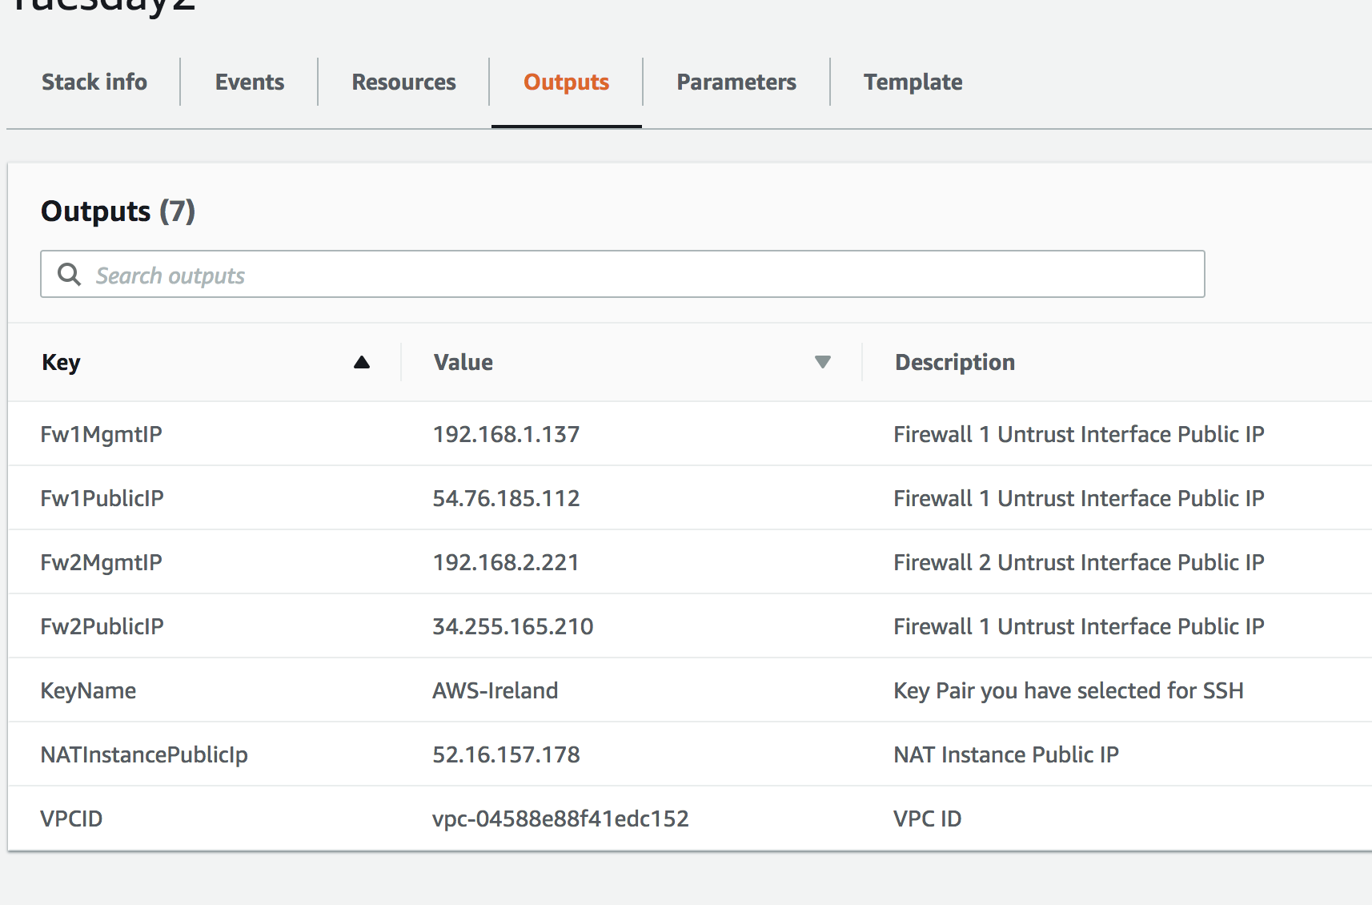

Figure 7 Stack Output with IP Address Allocation

# Accessing the Firewall

In order to access the firewall’s web UI or the CLI, it is recommended that you use the NAT instance that has been deployed in the Transit VPC. In order to do that you will need to setup an SSH tunnel from your localhost to the remote NAT instance.

For Web UI:

$ssh -i <AWS SSH key> -l ec2-user <public IP address of NAT instance> -L 4000:<private IP address of fw eth0>:443 -nNtv

You can then point your browser to https://localhost:4000 For CLI:

$ssh -i <AWS SSH key> -l ec2-user <public IP address of NAT instance> -L 4000:<private IP address of fw eth0>:22 -nNtv

You can now ssh to localhost:4001 using the panadmin/Pal0Alt0123! credentials.

$ssh admin@localhost -p 4001

NOTE: You can use any port of you choosing other than 4000

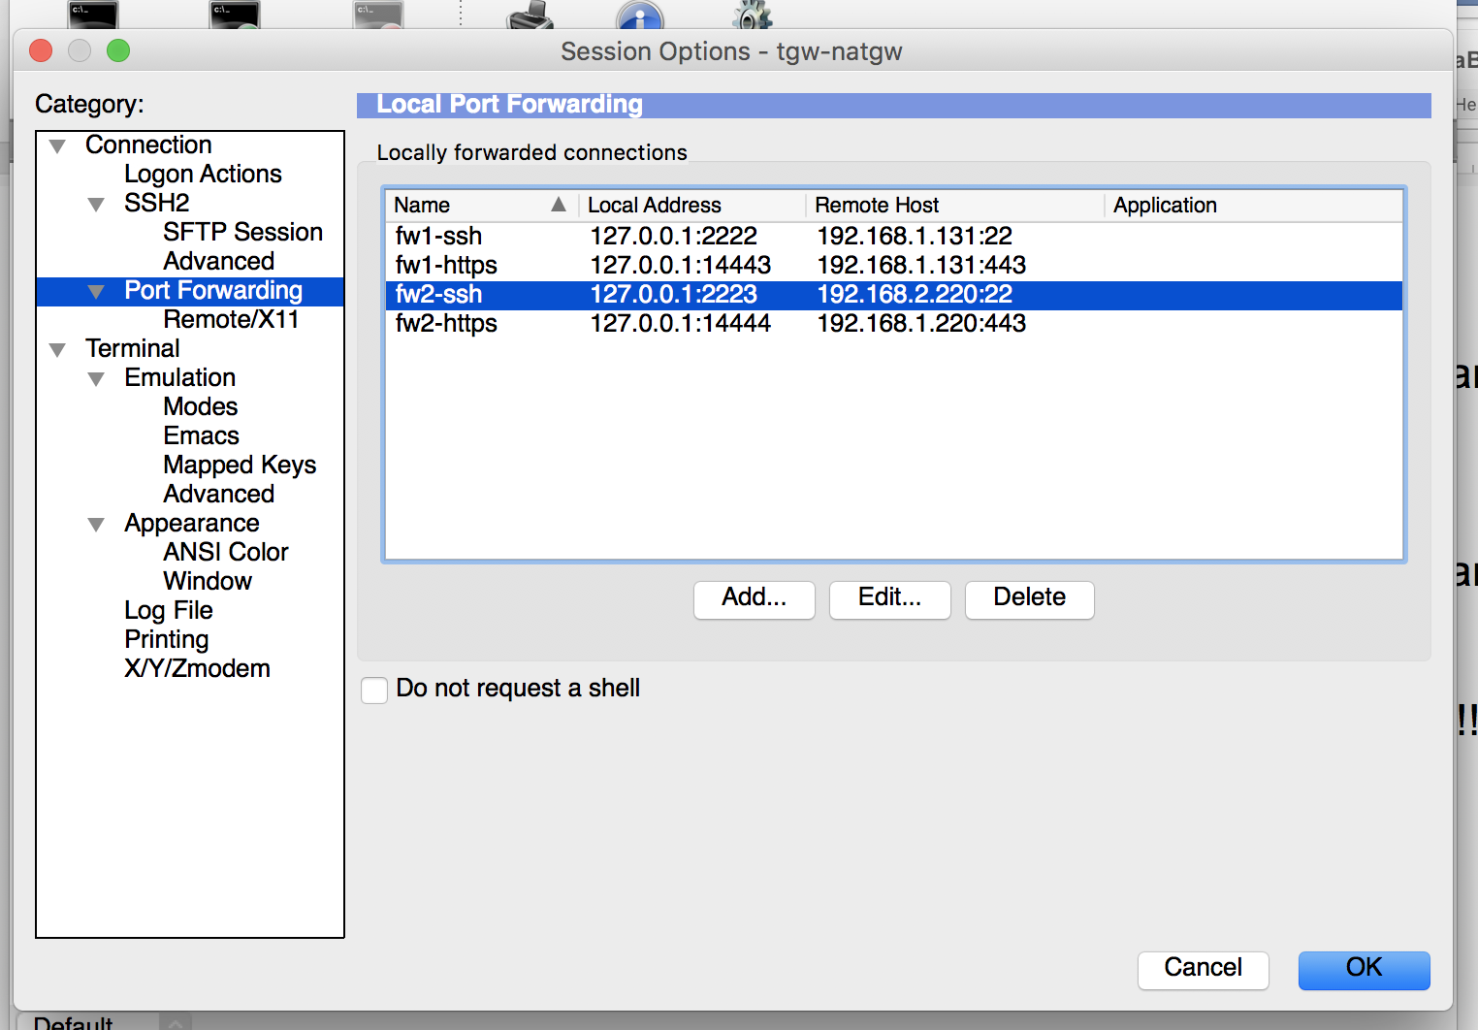

Figure 8 SecureCRT with Port Forwarding

# Testing the Deployment

1. Login to the firewalls via a browser.

Verify that the Lambda function has updated the firewall with a route to the spoke VPCs and updated the untrust interface address object.

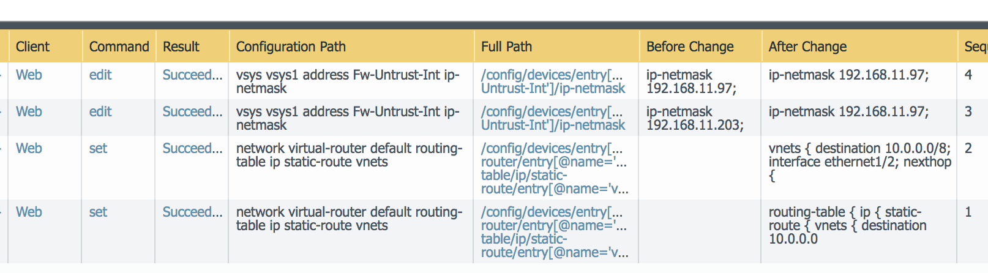

Figure 9 Configuration log showing firewall updates from Lambda

Figure 10 Firewall Changes From Lambda API calls

1. Test Connectivity

The firewall is configured with a NAT rule for ssh access to the server and Web Access to the test server on nonstandard ports.

The test url is http://<fwpublicip>/index.php

The firewall public ip can be obtained from the stack output

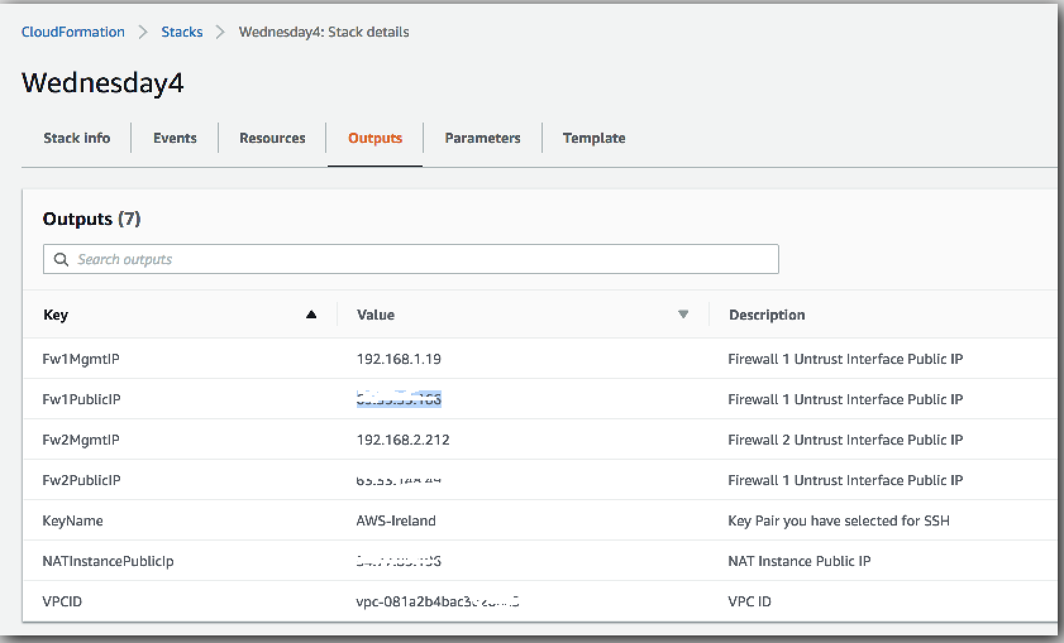

Figure 11 Stack output

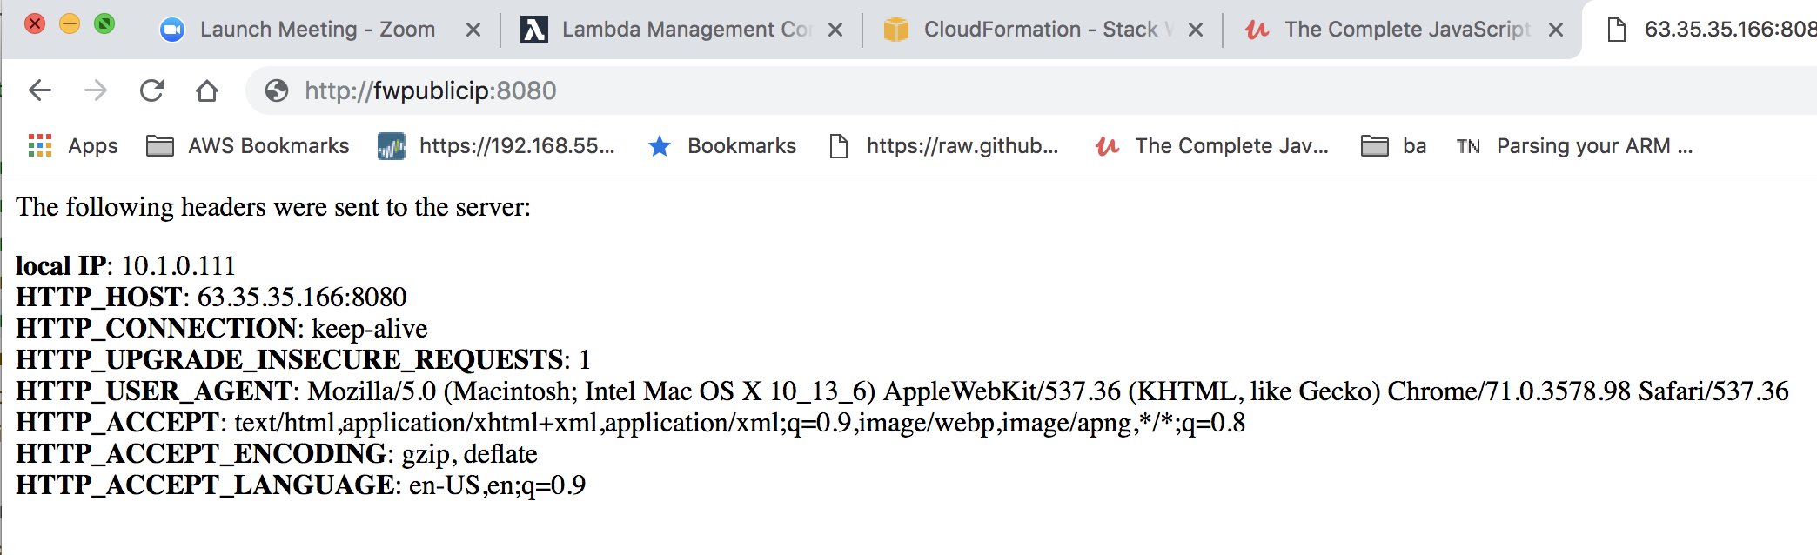

Figure 12 Server test page

# Cleanup

You can clean up the setup by deleting the stack deployed. You may have to manually delete some resources that were created by Lambda functions.